GIT COMMANDS

**GIT PUSH**

* git init
* git add .
* git status
* git commit -m 'My message'
* git remote add origin https://github.com/karthi290598/natours.git
* git push -u origin master

**GIT PULL**

* git pull https://github.com/karthi290598/natours.git
* git add .
* git status
* git commit -m 'My message'
* git remote add origin https://github.com/karthi290598/natours.git
* git push -u origin master

**GIT UPDATE**

* git update-git-for-windows

NPM Commands

* npm install or npm I 🡪 Installs packages in json
* npm install <package name>
* npm run compile sass 🡪 Example to run script called compile sass in json file

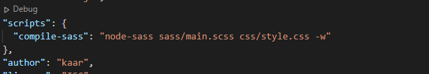

Hyper config

